***Billion-Dollar Dreams: India's Startup Saga***

**Nirmal Sai Swaroop Janapaneedi**

**Introduction**

In the heart of the world's fastest-growing major economy, a revolution is unfolding. India's startup ecosystem has become a crucible of innovation, ambition, and unprecedented growth. The country, with its vibrant entrepreneurial spirit, is home to numerous startups that have not only disrupted traditional industries but also created new markets and opportunities.

This project delves into the stories of Indian startups that have achieved remarkable feats. From the bustling streets of Bengaluru to the tech hubs of Noida, we explore how these companies have turned audacious ideas into billion-dollar realities. Through data-driven analysis, this report aims to uncover the patterns, challenges, and triumphs that define India's startup saga. It offers insights into the factors that propel young companies from simple beginnings to the forefront of the global business stage.

**Objective of the Project**

The primary objective of this project is to analyse the growth trajectory of Indian startups, identify key factors contributing to their success, and understand the broader trends within the ecosystem. By leveraging data analytics, we seek to draw actionable insights that can guide entrepreneurs, investors, and policymakers in fostering a more robust and sustainable startup environment.

**Key Findings**

* The concentration of successful startups in specific regions like Bengaluru and Noida.
* Common traits among billion-dollar startups, including innovation, scalability, and market demand.
* Challenges faced by startups, such as regulatory hurdles and access to funding.

**Technologies and Tools Used**

In this project, several technologies and tools were employed to analyse the data and generate insights. These tools facilitated data manipulation, visualization, and interpretation, enabling a thorough exploration of India's startup ecosystem.

**Libraries and Tools**

1. **Pandas**: Used for data manipulation and analysis. Pandas allowed for efficient handling of large datasets, enabling tasks such as data cleaning, merging, and transformation.
2. **NumPy**: Provided support for large, multi-dimensional arrays and matrices, along with a collection of mathematical functions to operate on these arrays. It was essential for numerical computations and optimizing data processing tasks.
3. **Matplotlib**: A fundamental plotting library in Python, Matplotlib was used to create static, animated, and interactive visualizations. It was instrumental in visualizing data trends, distributions, and comparisons.
4. **Seaborn**: Built on top of Matplotlib, Seaborn was used for creating more advanced and aesthetically pleasing visualizations. It facilitated the creation of complex plots such as heatmaps, box plots, and violin plots, enhancing the overall analysis.

**Data Sources**

* **Primary Dataset**: The data analysed in this project was obtained from sources like Kaggle, government databases, startup directories, etc. The dataset included information on various startups, their founding dates, locations, funding rounds, and valuations.
* **Supplementary Data**: In addition to the primary dataset, other sources such as industry reports, news articles were referenced to provide context and enrich the analysis.

**Data Preparation**

Effective data analysis begins with thorough data preparation. This section outlines the steps taken to load, clean, and prepare the dataset for exploration and analysis.

**Importing Libraries**

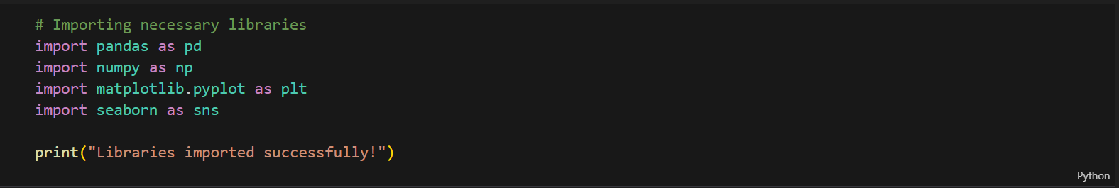These libraries formed the backbone of the analysis, providing essential tools for data processing and visualization.

**Data Loading**

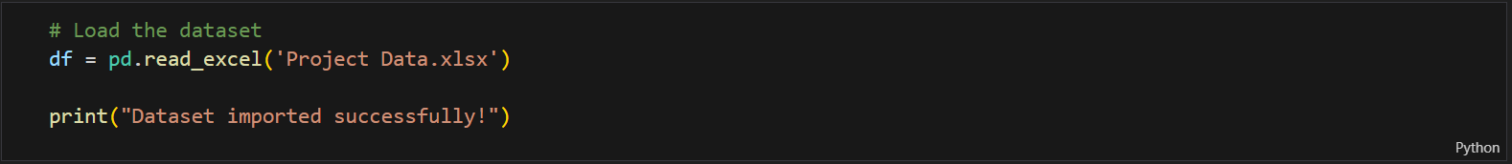The next step involved loading the dataset into a Pandas Data Frame. The dataset contains key information about various Indian startups, such as their founding dates, locations, sectors, funding rounds, and valuations.

The data was successfully loaded and structured into a Data Frame, allowing for easy manipulation and analysis.

**Data Cleaning and Pre-processing**

Data cleaning and preprocessing are critical steps in ensuring the accuracy and reliability of the analysis. This involved handling missing values, correcting data types within the dataset.

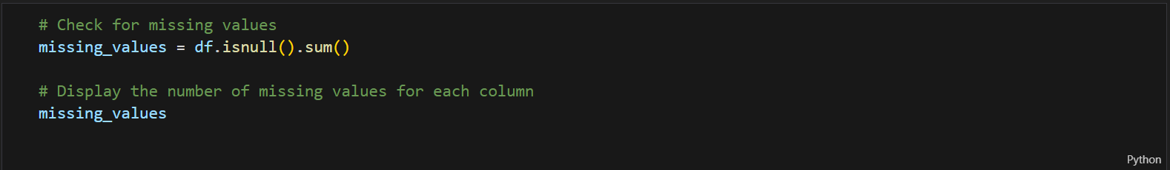**Handling Missing Values**

Depending on the results, we handle missing values. We might choose to fill them with a default value, the mean/median, or remove rows/columns with missing data.

**Correcting Data Types**

Data types were adjusted where necessary to ensure proper analysis.

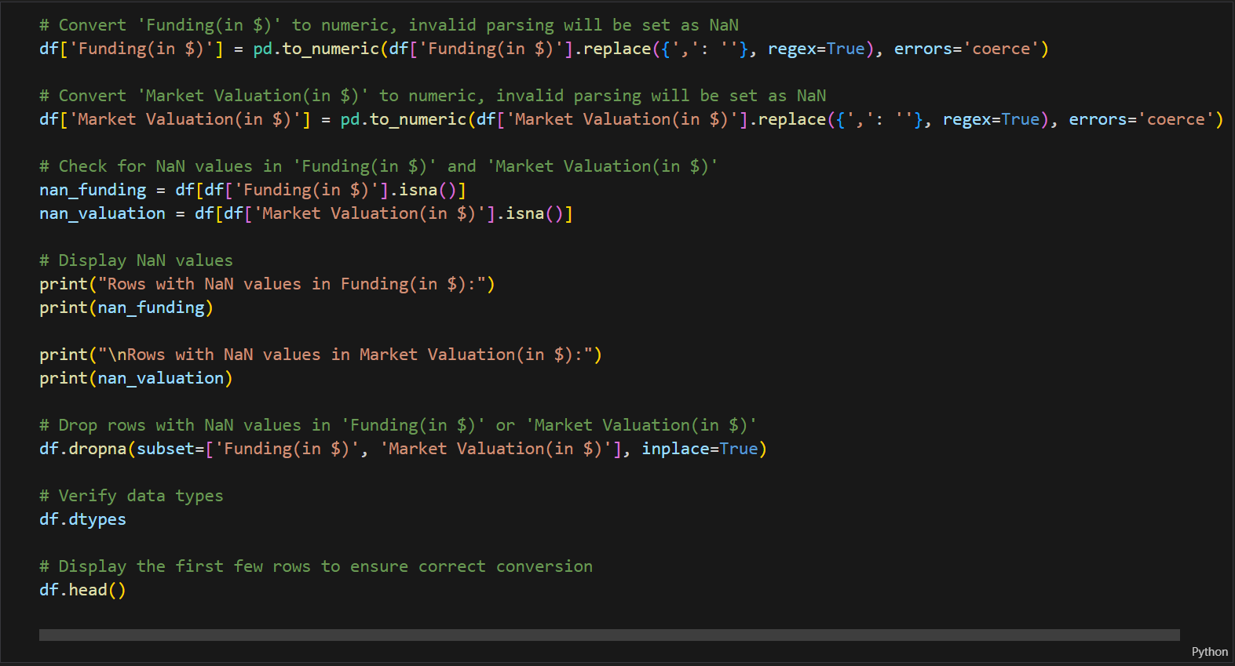

**Exploratory Data Analysis (EDA)**

Exploratory Data Analysis (EDA) is a crucial step in understanding the dataset, identifying patterns, and uncovering insights that can guide further analysis. This section presents the key visualizations created during EDA, accompanied by detailed interpretations.

Let’s look at different aspects of the data analysis and questions which I have come up regarding the data set one after the other.

1. **Understanding startup distribution by state**

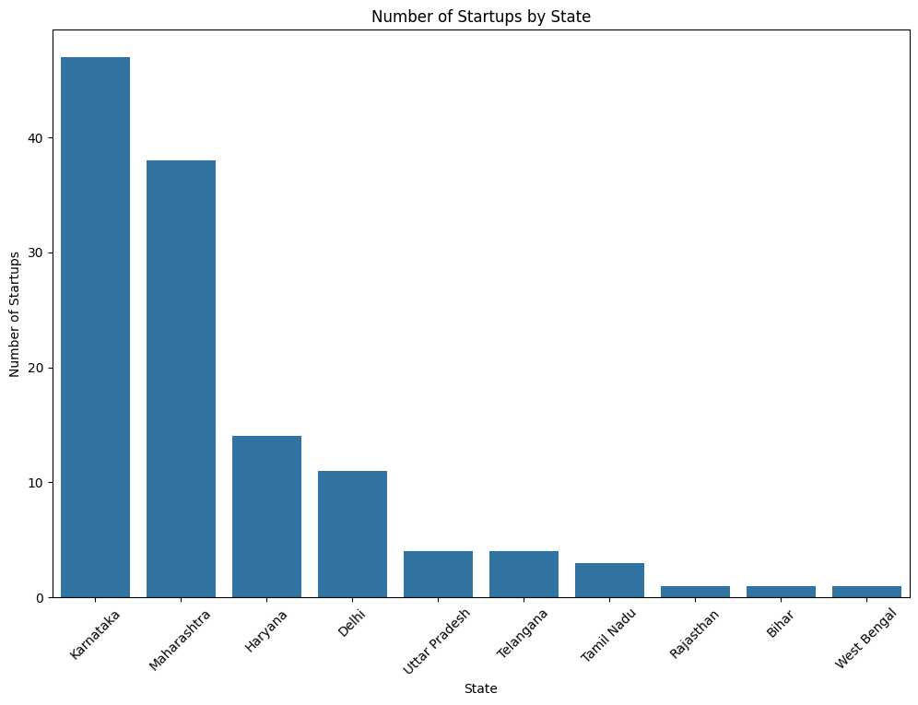**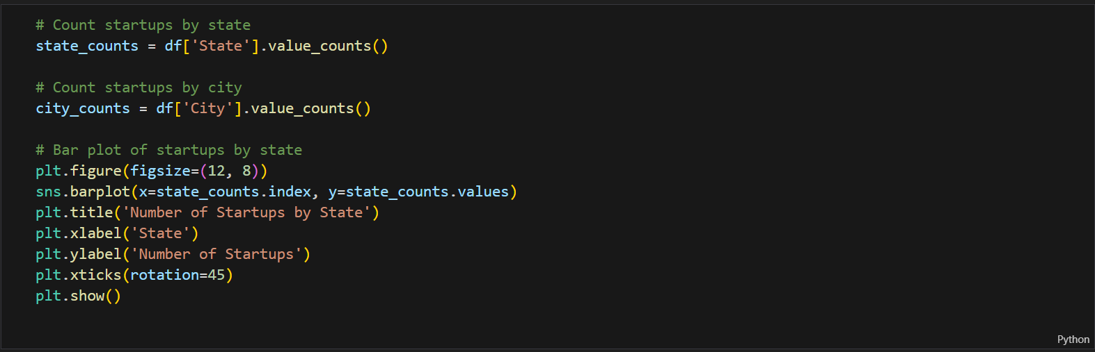Visualization:**

**Interpretation:**

The visualization shows the number of startups by state in India, with Karnataka having the most, followed by Maharashtra, Haryana, and Delhi. It highlights the uneven distribution of startups across the country, with some states like Karnataka and Maharashtra emerging as prominent startup hubs, while others have relatively fewer startup activities. This data can provide insights into the regional differences in the maturity and growth of the Indian startup ecosystem.

1. 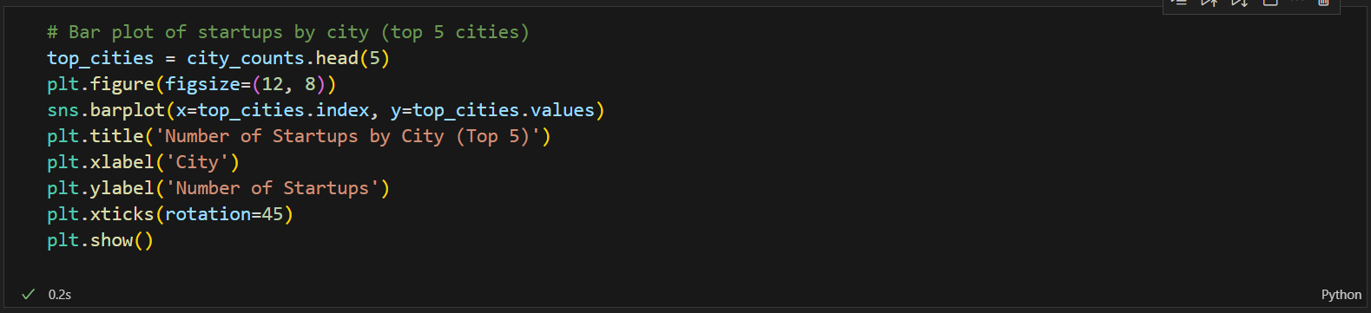**City-wise Start up distribution**

**Visualization:**

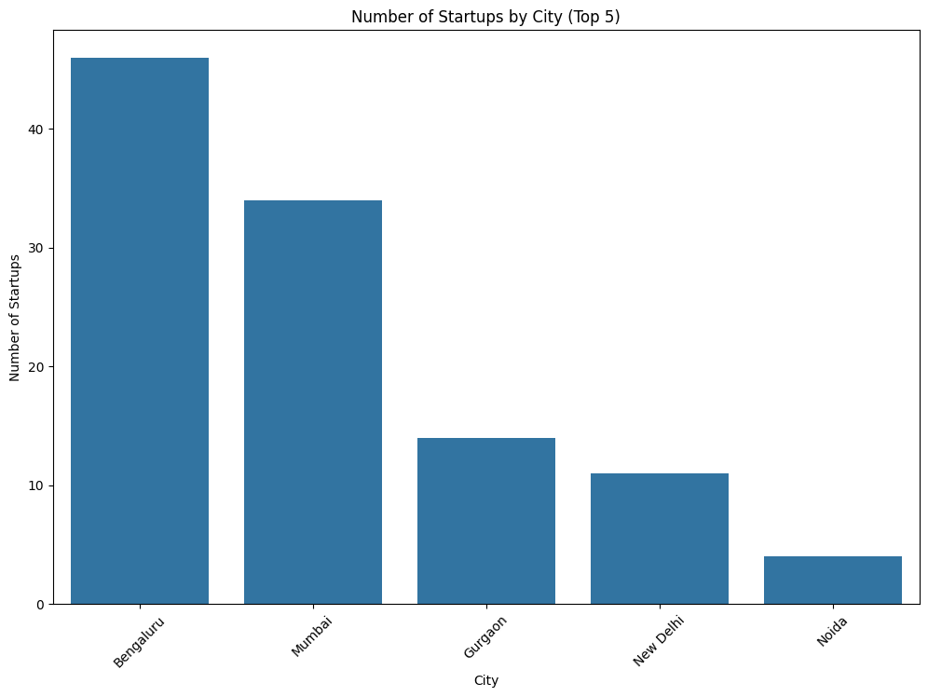**Interpretation:**

The graph shows the top 5 Indian cities by number of startups, with Bengaluru having the highest number, followed by Mumbai. Gurugram, New Delhi, and Noida have significantly fewer startups compared to the top two cities. In my opinion it suggests that Bengaluru, Mumbai and Gurgaon, to some extent, have emerged as the leading startup hubs in the country, while other cities have yet to catch up in terms of startup ecosystem development.

1. **Startups in South and North India**

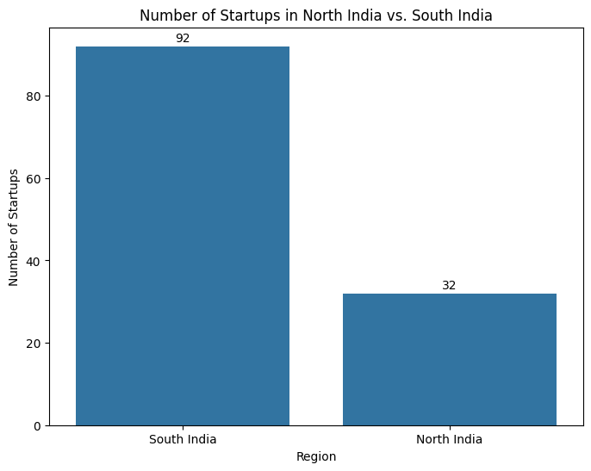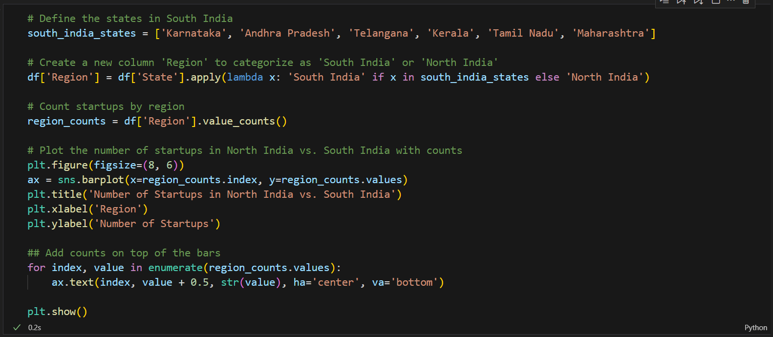**Visualization:**

**Interpretation:**

The graph compares the number of startups between North India and South India. Upon my understanding, the startup ecosystem is more developed and thriving in the southern regions of India, likely driven by factors such as access to talent, funding, infrastructure, and a conducive business environment. In contrast, the northern regions of India appear to lag behind in terms of startup growth and activity. This disparity highlights the need to foster a more balanced and inclusive startup ecosystem across different regions of India, potentially through targeted policies & investments.

1. 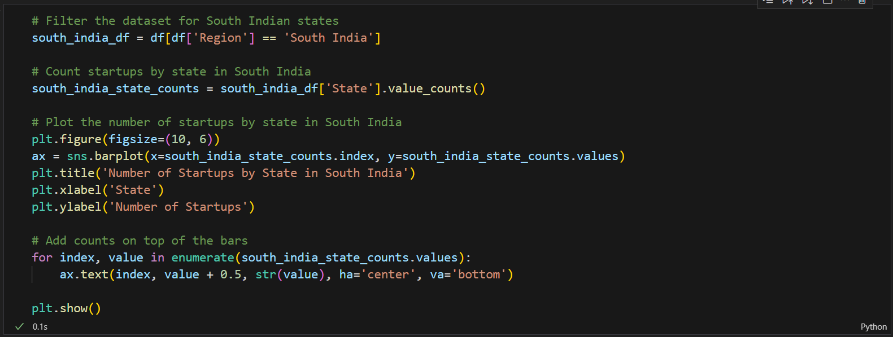**State-wise South Indian startups**

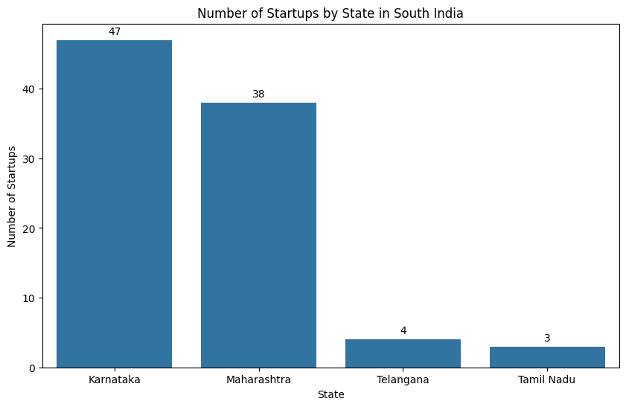**Visualization:**

**Interpretation:**

In my understanding of the graph, it shows that Karnataka has the highest number of startups in South India, significantly more than Maharashtra, Telangana, and Tamil Nadu. This suggests Karnataka has become the leading startup hub in the southern region, underscoring the need to address regional imbalances and promote more balanced startup growth across South India.

1. 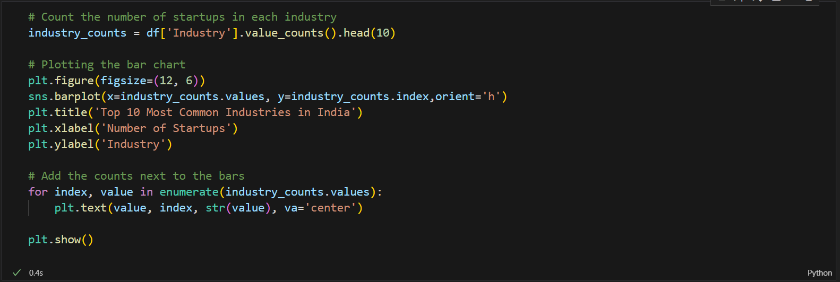**Industries where startups are growing immensely**

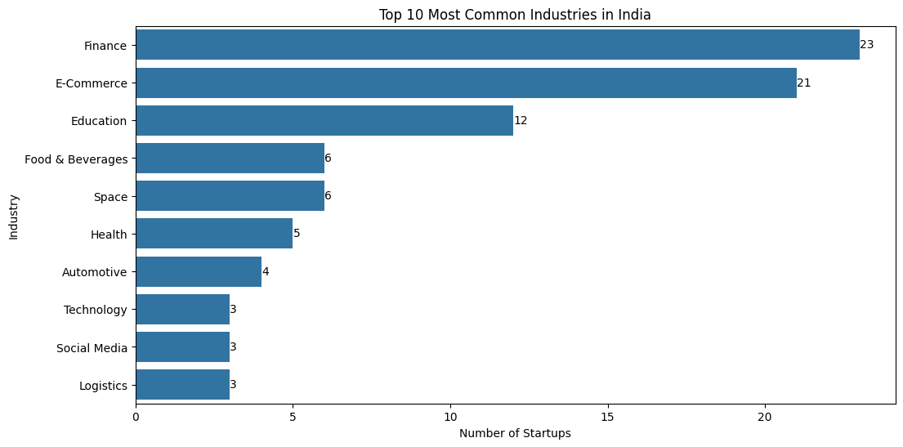**Visualization:**

**Interpretation:**

The top 3 most common industries for startups in India are Finance, E-Commerce, and Education. This indicates that these sectors have seen significant entrepreneurial activity and growth potential. The next tier of industries includes Food & Beverages and Space, both with 6 startups each, followed by Health, Automotive, Technology, social media, and Logistics, each with 3-5 startups. The wide variation in the number of startups across different industries suggests that some sectors are more suitable to entrepreneurship and innovation in terms of market behaviour and demand than others in the Indian market.

1. 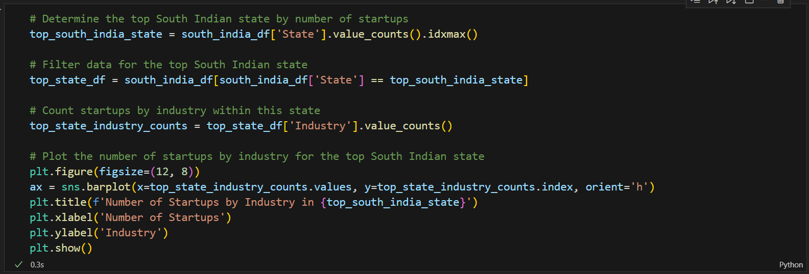**Industrial distribution of top South Indian state**

**Visualization:**

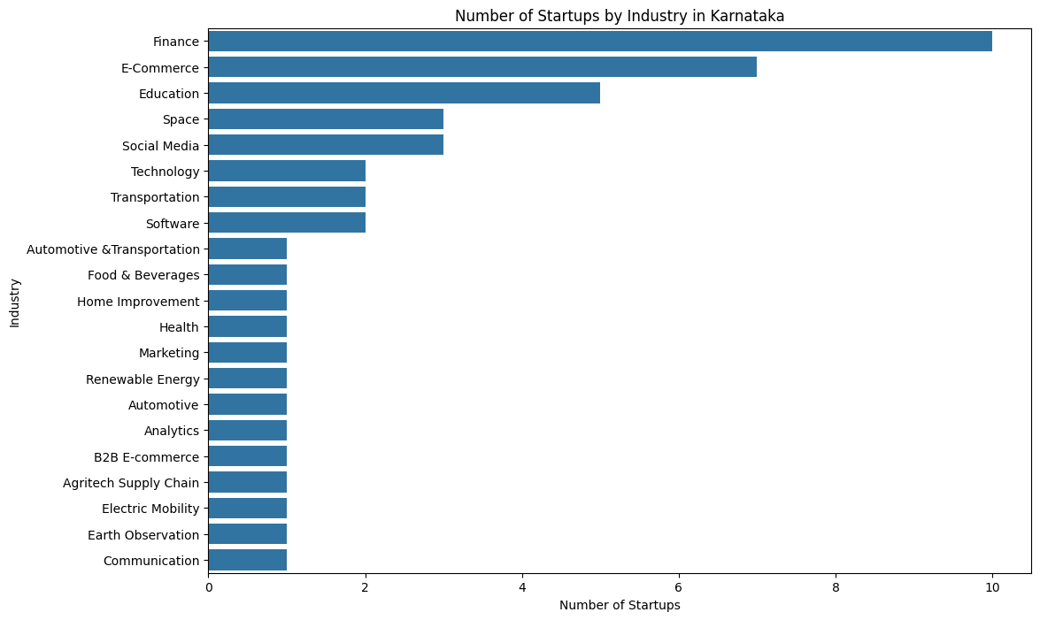

Interpretation:

The top three industries with the highest number of startups in Karnataka are Finance, E-Commerce, and Education, suggesting, these sectors have a strong startup ecosystem in the state. The graph shows a diverse range of industries represented, from traditional sectors like Automotive and Food & Beverages to emerging areas like Renewable Energy and Electric Mobility, indicating a thriving and multifaceted startup landscape in Karnataka. Overall, the graph offers a detailed breakdown of the startup activities across different industries in the state of Karnataka, highlighting its position as a prominent startup hub in India.

1. 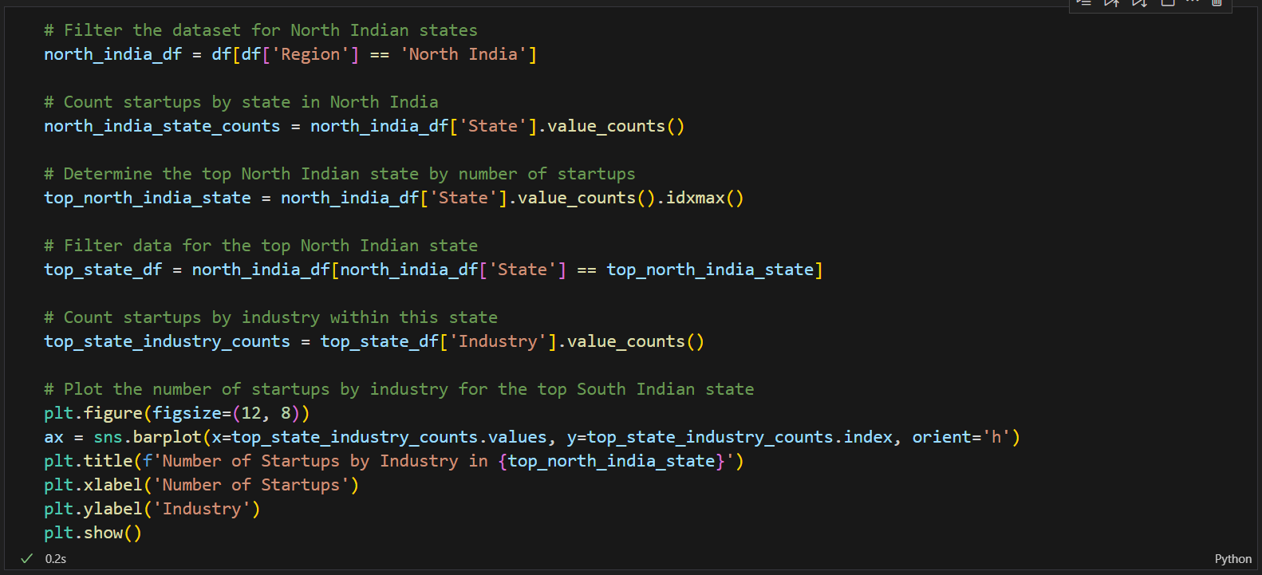Industrial distribution of top North Indian state

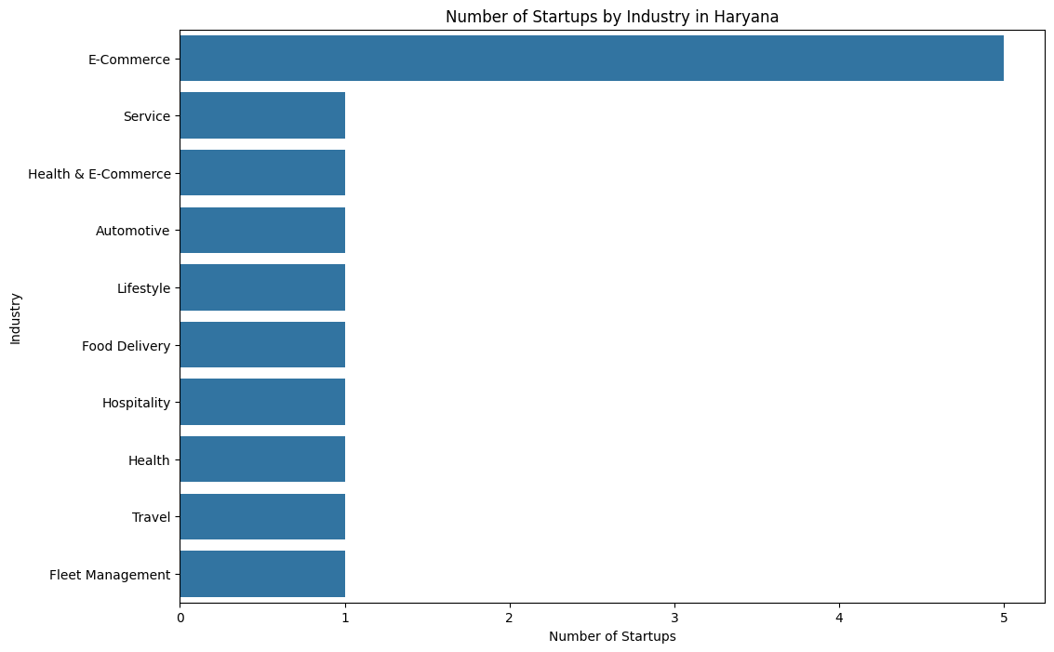Visualization:

Interpretation:

The given bar chart shows the number of startups by industry in Haryana. E-Commerce dominates the startup scene, with significantly more startups than any other industry. Service and Health & E-Commerce follow, while other industries like Automotive, Lifestyle, and Food Delivery have an equal but smaller number of startups. This suggests a strong preference for digital and service-oriented industries in the region.

1. 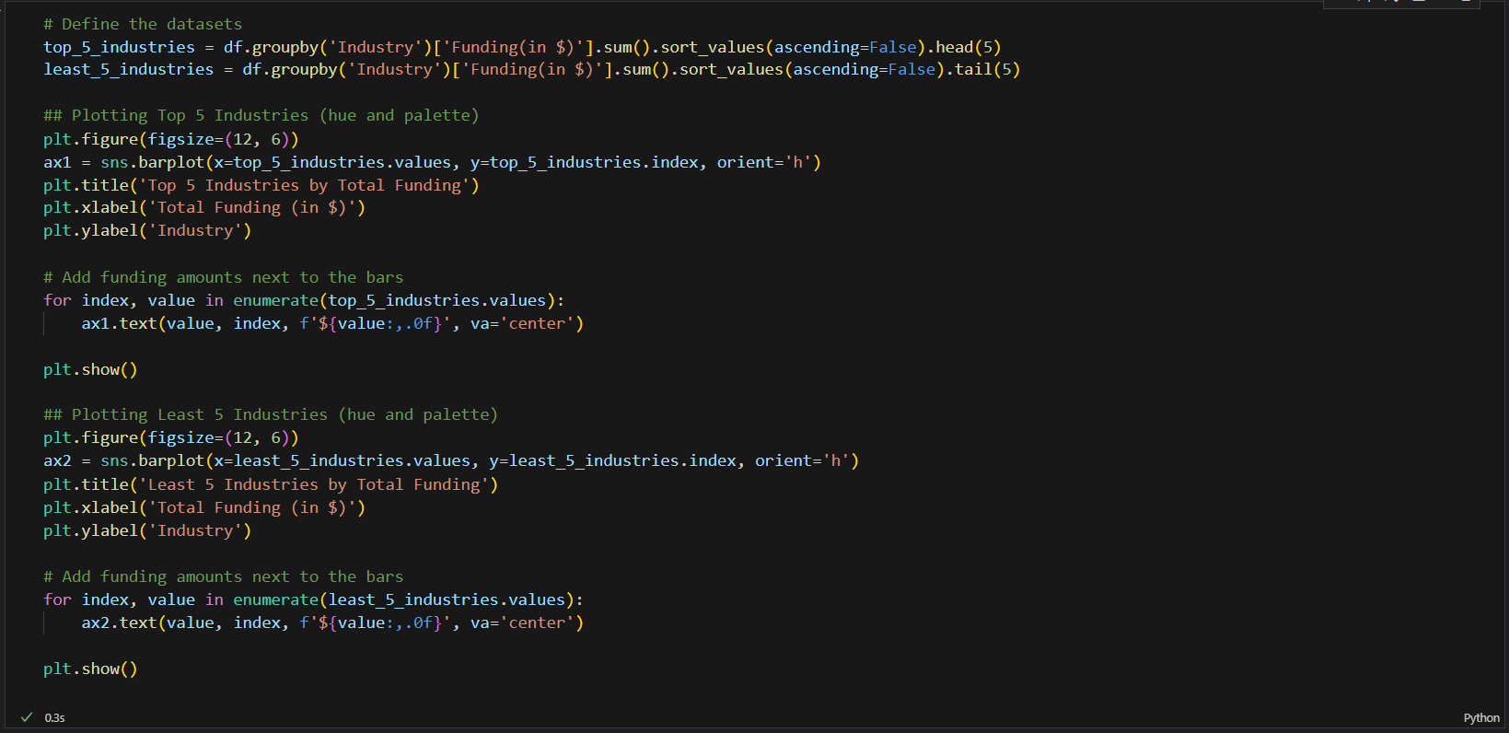Industries and the relation with their funding scale

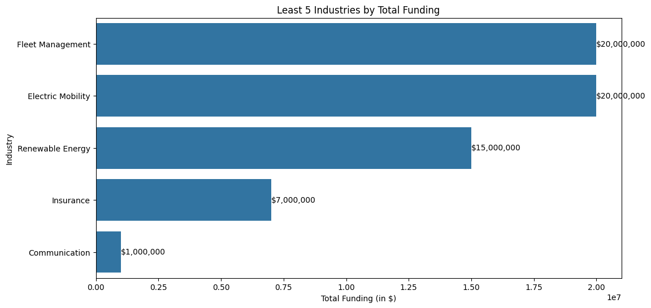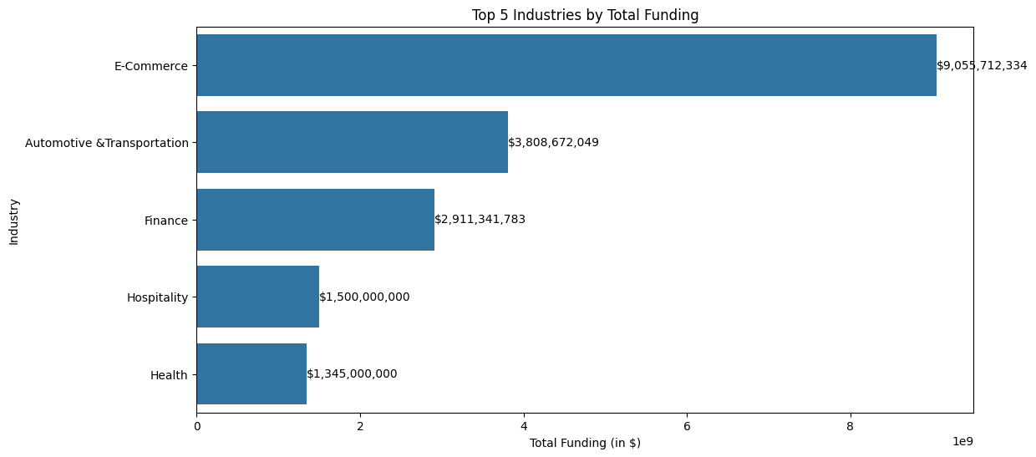Visualization:

Interpretation:

As per my understanding, I can provide the following summary of the insights from both visualizations:

The funding landscape across industries in this startup ecosystem shows significant disparities. E-Commerce dominates with over $9 billion in total funding, far surpassing other sectors. Automotive & Transportation and Finance also attract substantial investments, each securing over $2.9 billion. This indicates a strong investor focus on digital commerce, mobility solutions, and financial technologies.

In contrast, the least funded industries—including Fleet Management, Electric Mobility, and Renewable Energy—receive comparatively modest investments ranging from $15 million to $20 million. This stark difference in funding allocation highlights the current market priorities and potentially underserved sectors.

The wide gap between the most and least funded industries suggests opportunities for diversification in investment strategies. It also points to potential areas for growth and innovation in less-funded sectors, which could attract more attention from investors looking for emerging opportunities in the startup ecosystem.

1. 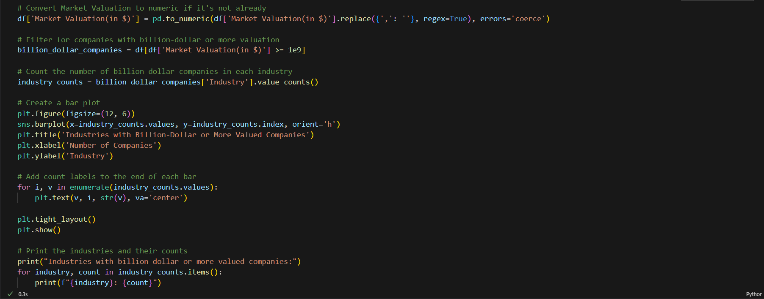**Industries that have maximum billion-dollar companies**

**Visualization:**

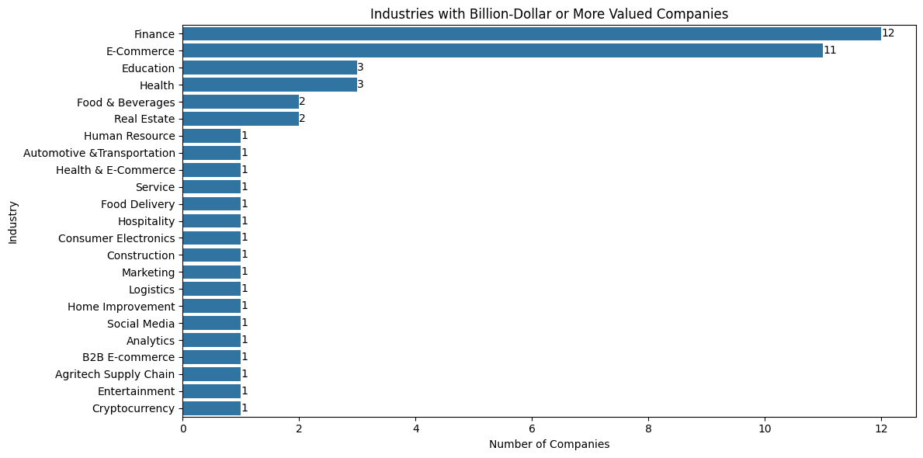**Interpretation:**

The graph illustrates a clear concentration of high-value companies in a few key sectors. Finance and E-Commerce dominate the landscape, with 12 and 11 billion-dollar companies respectively, attracting significant investments and scaling potential. Overall, companies across 22 different industries indicates a broad-based potential for high-value company creation in the startup ecosystem

1. 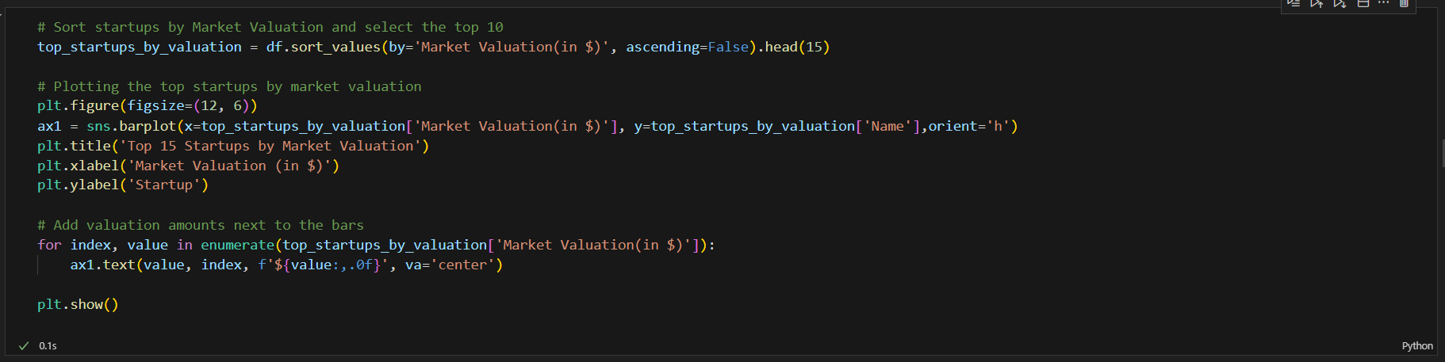Which startups and industries have the highest market valuation?

Visualization:

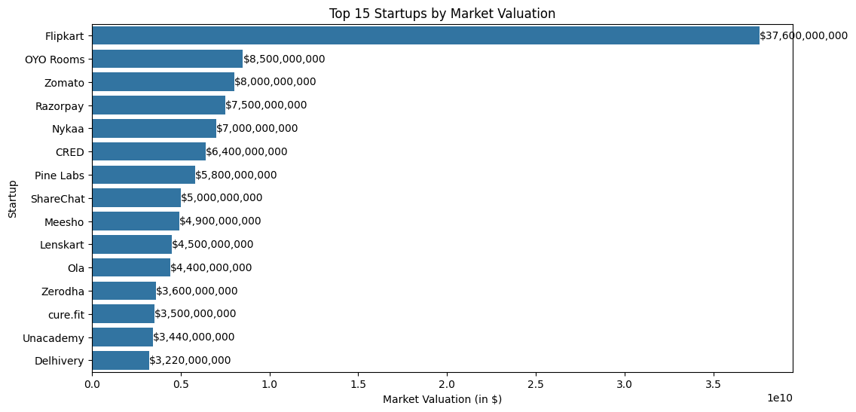Interpretation:

The above graph reveals that within the top industries, individual companies like Flipkart, OYO Rooms, and Zomato have achieved remarkably high valuations, with Flipkart standing out at $37.6 billion. The top 15 startups span various sectors including e-commerce, hospitality, food delivery, fintech, and education technology, reflecting the diverse nature of India's unicorn landscape. However, the steep drop-off in valuations after the top few companies suggests a highly skewed distribution of value among startups, with a select few capturing a disproportionate share of the market.

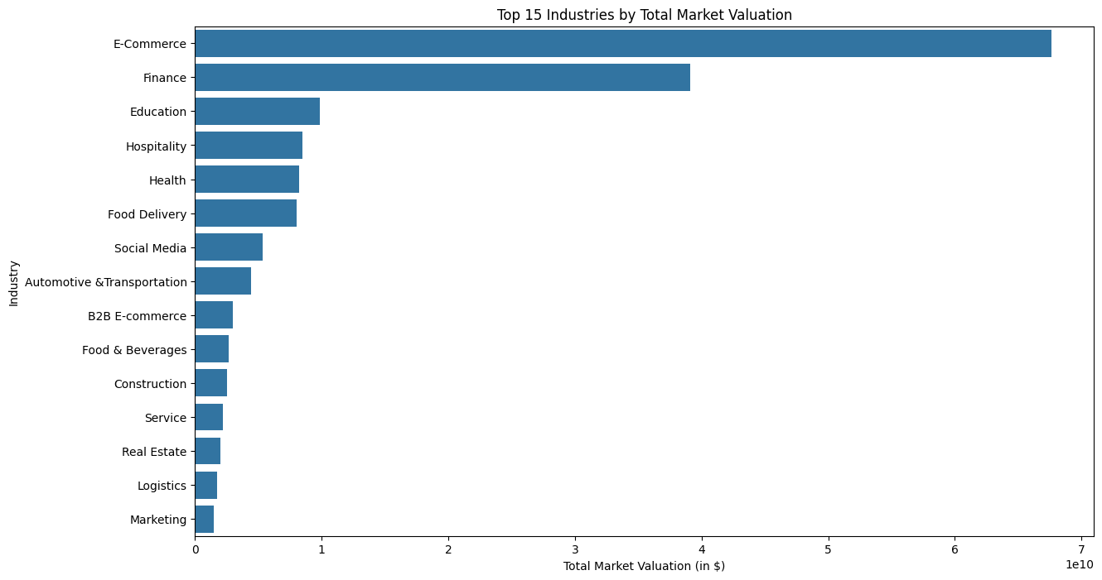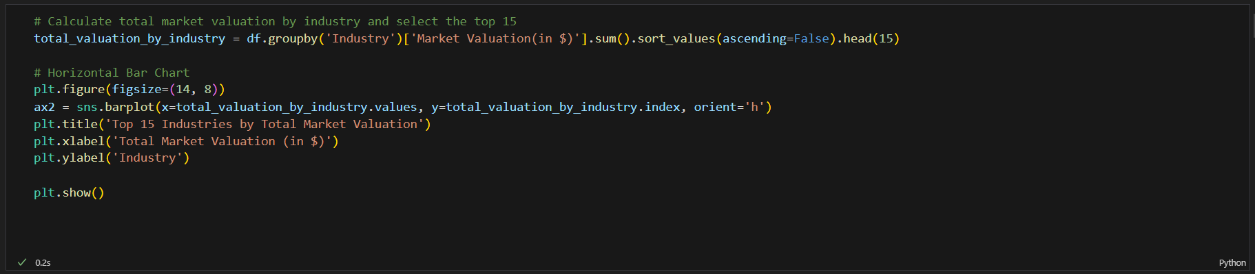Visualization:

Interpretation:

Based on the visualization, E-Commerce and Finance dominate the industry landscape by total market valuation, followed by Education, Hospitality, and Health. This indicates where the bulk of startup value is being created across industries.

1. 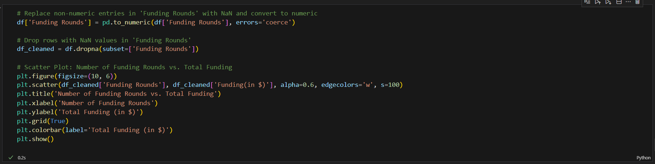Correlation between number of funding rounds and total funding received by the company.

Visualization:

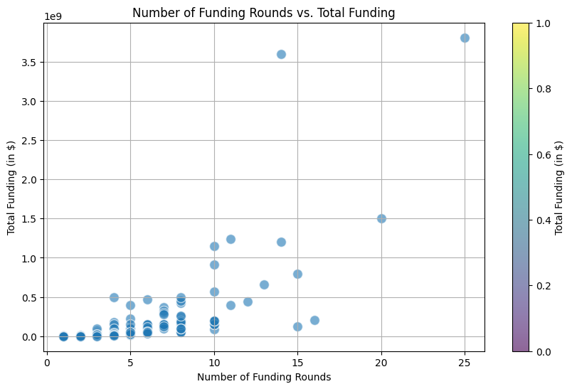Interpretation:

This scatter plot shows that there is a general trend indicating that as the number of funding rounds increases, the total funding amount tends to rise as well. However, there's significant variation, with some entities receiving high funding amounts in fewer rounds, and others having many rounds but lower total funding. The highest funding amount, around $3.8 billion, is associated with 25 funding rounds.

1. 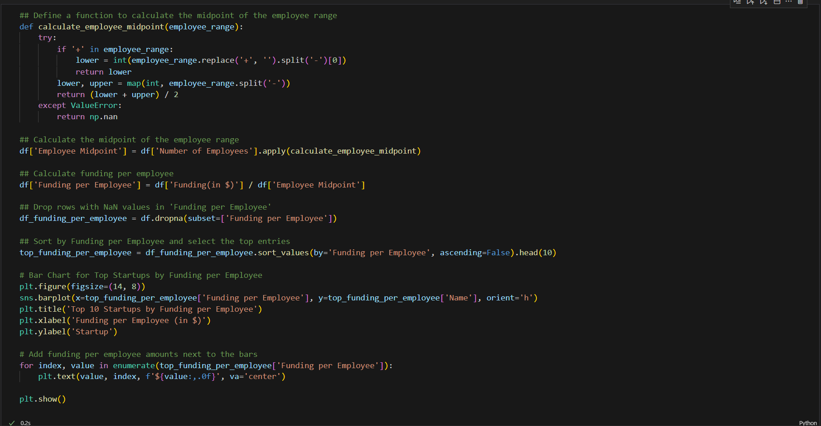Startups with highest funding per employee

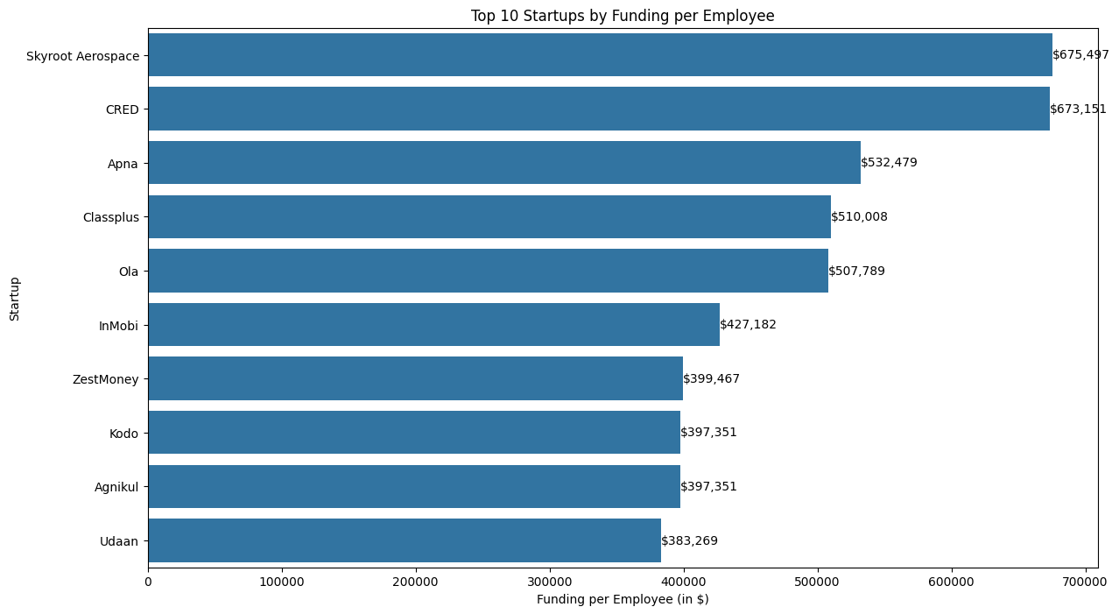Visualization:

Interpretation:

The chart shows how efficiently startups are using their funding relative to their employee count. A higher funding per employee ratio could indicate either substantial financial backing or a lean operational model. The list includes companies from various sectors, such as aerospace, fintech, ride-hailing & e-commerce, indicating that high funding per employee isn't limited to any single industry.

1. 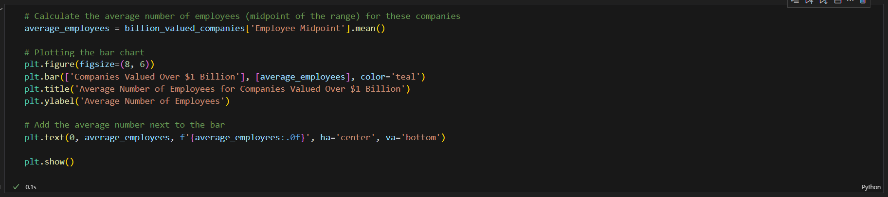Average number of employees for companies valued over 1 billion

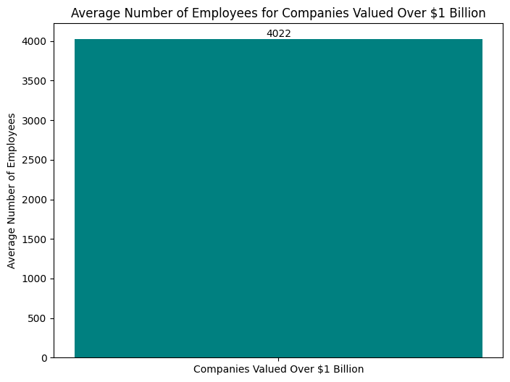Visualization:

Interpretation:

This bar chart displays the average number of employees for companies valued over $1 billion, commonly known as "unicorn" companies. The single bar indicates that these high-value companies have an average of 4,022 employees. The large employee count suggests these companies have likely moved beyond the early startup phase and are in a growth or maturity stage. Managing a workforce of this size implies these companies have complex operational needs and significant costs.

1. 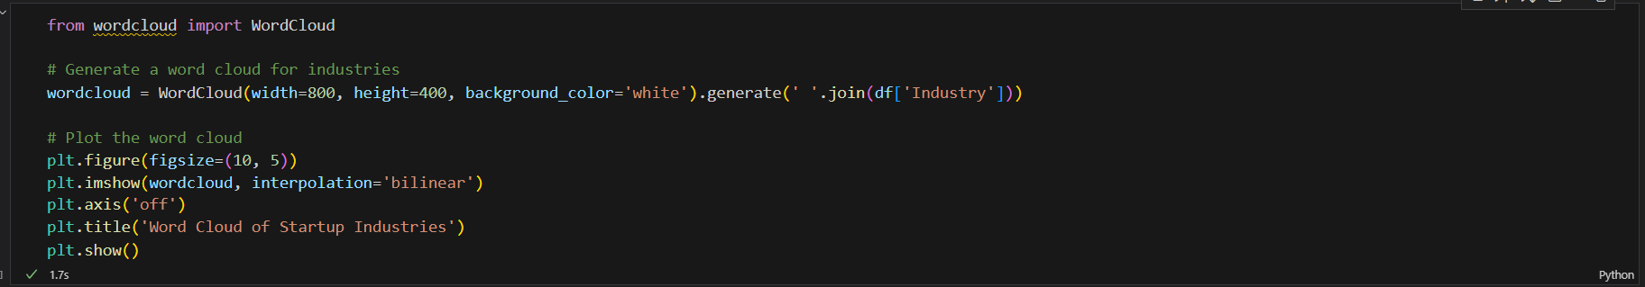Dominant trends in the Indian startup ecosystem

Visualization:

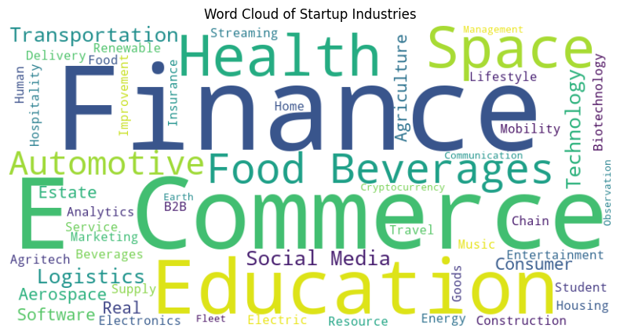Interpretation:

The word cloud visualization provides insights into the prevalent industries and sectors among startups. Finance, Health, Commerce, Education, and Space appear to be the most prominent startup sectors, based on their larger font sizes. The cloud shows a wide range of industries, from traditional sectors like Automotive to emerging fields like Renewable energy. Words like "Space", "Mobility" and "Agritech" highlight startup activity in cutting-edge and evolving sectors. This visualization effectively summarizes the diverse landscape of startup industries, highlighting both traditional and emerging sectors where entrepreneurial activity is concentrated.

1. 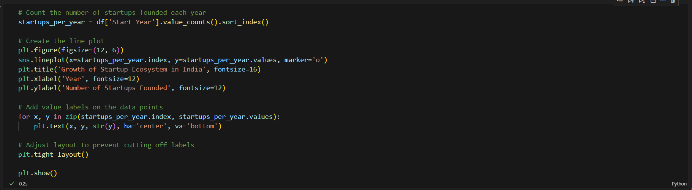Growth of startup eco-system in India

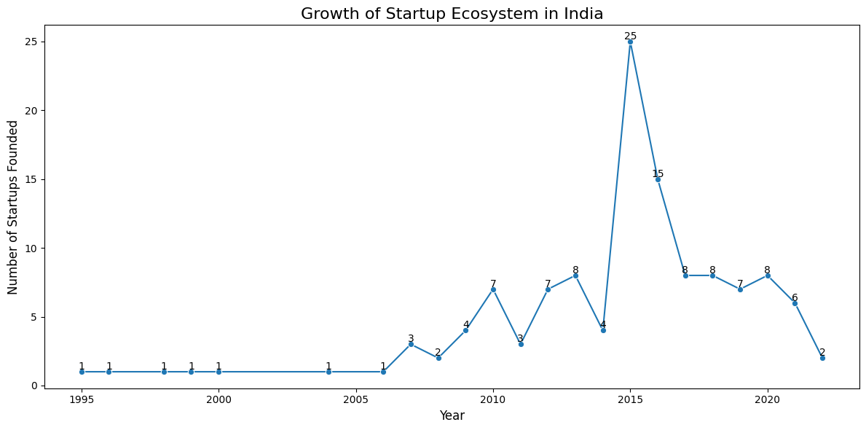Visualization:

Interpretation:

This is the growth of startup culture in India. The graph started to grow after 2005 and peaked in terms of numbers of startups founded in the year 2015. However, again the pace at which startups have been founded has reduced a little in my opinion (it is to be noted that not all the startups have been included in the dataset that are founded in India, so the info may or may not be the most apt one). There are various sectors as we have seen so far where companies have been coming up and valued heavily in terms of market valuation that marks its success.

Conclusion

The journey through India's startup ecosystem reveals a dynamic landscape filled with opportunities, challenges, and unprecedented growth. The analysis that I have conducted in this project sheds light on key aspects that define the success and struggles of Indian startups, offering valuable insights for entrepreneurs, investors, and policymakers alike.

Summary of my Insights –

* Regional Hubs of Innovation: Bengaluru, Mumbai, Delhi, and Noida have emerged as the epicentres of startup activity in India. The concentration of resources, talent, and investor networks in these cities creates a fertile ground for entrepreneurial ventures to thrive.
* Valuation Growth & Investor Confidence: The surge in startup valuations, particularly since 2015, reflects a robust and maturing ecosystem. The rise of unicorns underscores the potential of Indian startups to scale rapidly and compete on a global stage.
* Sectoral Dominance: Technology-driven sectors like FinTech, E-commerce, and SaaS lead the charge, driven by digital transformation and consumer demand. However, traditional sectors like Healthcare and Education, while challenging, present opportunities for impactful innovations.
* Importance of Funding: External capital plays a pivotal role in the growth trajectory of startups. Multiple funding rounds are often associated with higher valuations, but success also depends on a clear vision and innovative approach.
* Sectoral Risks and Rewards: The variation in success rates across sectors highlights the need for startups to carefully evaluate the market, competition, and scalability before diving in.

**Implications for the future –**

In my opinion, the Indian startup ecosystem is poised for continued growth, with increasing support from government initiatives, investor interest, and a growing consumer base. However, sustaining this growth will require addressing challenges which I think are potential ones such as:

* Infrastructure and Regulatory Support: Expanding startup hubs beyond the current metropolitan areas and simplifying regulatory processes can foster innovation across the country.
* Sustainable Growth Strategies: Startups must focus on long-term profitability and sustainability, rather than just chasing high valuations.
* Diversification of Sectors: Encouraging innovation in underrepresented sectors such as Agriculture, Manufacturing, and Renewable Energy can lead to more balanced economic development.

**My Verdict –**

The journey through India's startup landscape is not just a reflection of past achievements but a testament to the relentless spirit of innovation that fuels the nation's entrepreneurial engine. The story of India's startups is one of resilience, creativity, and transformation—a saga that has redefined industries, created new markets, and put India on the global map as a powerhouse of ideas and innovation.

As we stand at the cusp of a new era, the insights drawn from this analysis provide more than just a retrospective glance; they serve as a beacon guiding the way forward. The successes and challenges of the past offer valuable lessons for the future, helping to shape strategies that can sustain and accelerate growth in this vibrant ecosystem.

**Inspiring the Next Generation:**

As we look ahead, the narrative of India's startups must also inspire the next generation of entrepreneurs. The stories of success, perseverance, and innovation are powerful motivators, encouraging young minds to dream big, take risks, and challenge the status quo. The future belongs to those who dare to innovate, and the insights from this analysis provide a solid foundation for aspiring entrepreneurs to build upon.

In conclusion, the story of India's startups is far from over. It is a living, evolving narrative that continues to unfold with each new idea, each new venture, and each new success. The insights from this project are not just a reflection of the past but a vision for the future—a future where India's startups continue to thrive, innovate, and make a lasting impact on the world.

**References**

**Data Sources:**

1. **Kaggle Datasets:**
   * *Indian Startups Dataset*. Retrieved from Kaggle.
2. **Government Databases:**
   * Ministry of Corporate Affairs, Government of India. (2023). *Startup India Initiative*. Retrieved from [Startup India](https://www.startupindia.gov.in/).
3. **Industry Reports:**
   * Nasscom. (2023). *Nasscom Startup Report 2023*. Retrieved from [Nasscom](https://nasscom.in/).
   * KPMG. (2022). *India Startup Ecosystem Report*. Retrieved from KPMG India.

**Relevant Articles and Studies:**

1. Singh, A., & Kaur, R. (2022). *The Rise of Startups in India: Challenges and Opportunities*. International Journal of Entrepreneurship and Innovation, 23(1), 45-60.
2. Gupta, S. (2021). *Digital Transformation and its Impact on Indian Startups*. Journal of Business Research, 134, 325-332.
3. Kumar, V., & Mehta, R. (2023). *Funding Dynamics in the Indian Startup Ecosystem*. Venture Capital Journal, 28(2), 112-128.
4. Sharma, P. (2022). *The Role of Government Policies in Shaping India's Startup Ecosystem*. Economic and Political Weekly, 57(14), 34-40.

**Search & Programming notes:** ChatGPT 4.0 mini

**Additional Resources:**

1. **Startup India Portal:**
   * *Startup India*. Retrieved from [Startup India](https://www.startupindia.gov.in/).
2. **NASSCOM:**
   * *NASSCOM India*. Retrieved from [NASSCOM](https://nasscom.in/).
3. **TechCrunch:**
   * Articles on Indian startups. Retrieved from TechCrunch.
4. **Failory:**
   * Article of 300 startups of India - [Website](https://www.failory.com/startups/india)

Thank You